**How to create a “perfect presentation”**

**Planning a presentation**

1. **Purpose** –what do we want people to think/feel.
2. **Agenda** – how do we make them think/feel that, what content do we use to do this.
3. **Desired Outcomes**

Do the planning in this order not picking content first as is often common.

**Opening a Presentation**

**5 types of openings**

* Ask a question
* A gift/thank you
* Tell a story
* Bring along a prop or image
* Give the audience a shock

**How to ensure what you want to portray is portrayed**

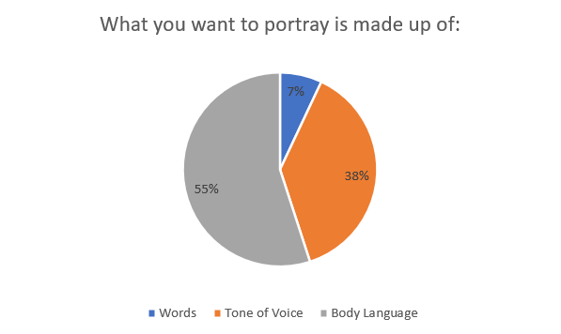

* This is why we should put on our cameras.

**Ending the presentation**

* Ask for questions enthusiastically, don’t just say “we will take questions now”.
* At the end of the presentation the slide order should go questions **and then** a brief summary of the project to end out as this will leave them not just thinking about whatever questions someone else may have asked that they might not even have found interesting or relevant; but instead, what we want them to be thinking of (not sure how this will work with the 10mins for presenting, 10 mins of questions).

**Other Tips**

* **What do you know that your audience knows – don’t tell them things they know**. This would apply to info about Lobitos and Piedritas, no point wasting time on that.
* **The judges have read our report.** Address the feedback and try not to repeat too much that they will already understand about our project.
* Told us that it was about our idea/solution not about us, we were just a tool to convey this so not being judged on how good we are at presenting.
* Only put bullet points on the screen (no more than you would read from a T-shirt) and obviously images, figures etc.

Each team member will have different strengths and each team will have different dynamics. Think about how best to use these to your advantage. For instance, think about who is going to present during your pitch, consider if you will involve the whole team or assign it to someone whose skill set or personality specifically matches the task. It's simple, the better preparation the better the pitch.

Think about the narrative you are trying to communicate. Ensure your pitch has a beginning, middle and end. Set the scene, define the problem. Consider the following questions:

Why is that an issue?

How does your design solve it?

Who is it benefitting?

How is it appropriate for the Lobitos and/or Piedritas context?

What happens after it is installed?